**Lab 1: Installation of SQL Server**

Step 1 : Search MS SQL Server Development Edition in your browser & download

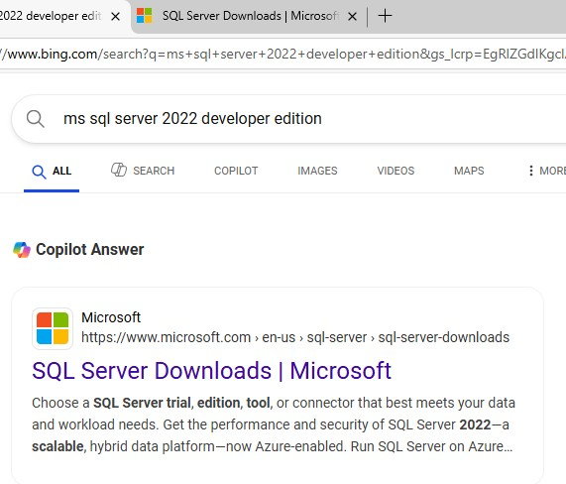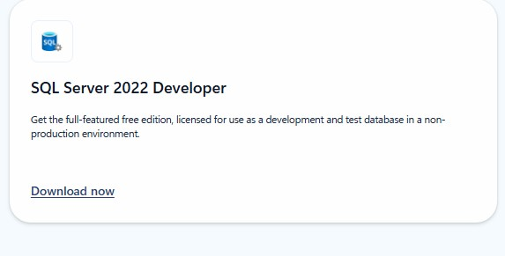

Step 2 : Install Package in PC

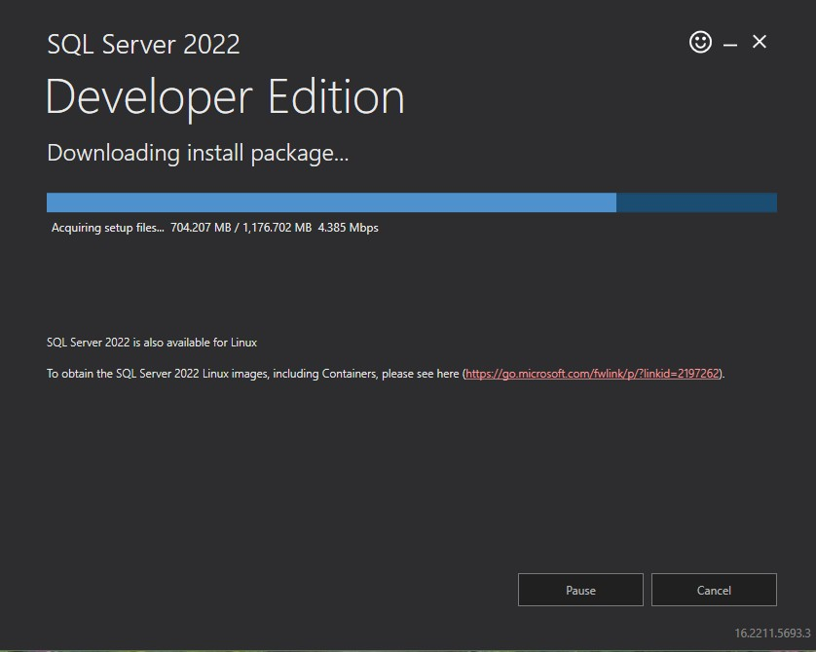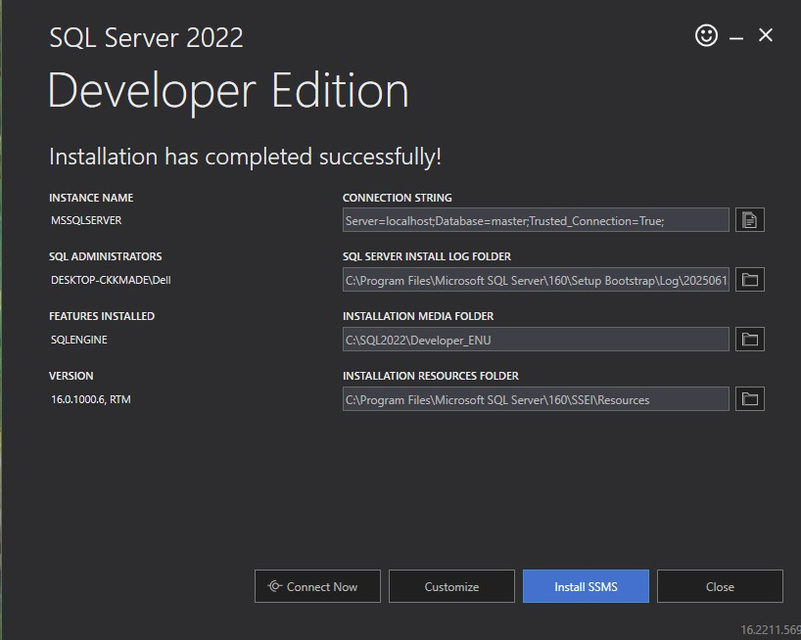

Step 3: Determine version of SQL Server Management Studio to Install & Launch

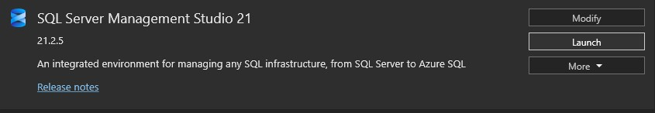

# Lab 2: Creating Data Base

Step 1 : Check Trust server certificate & press connect

Step 2 : Create New Database

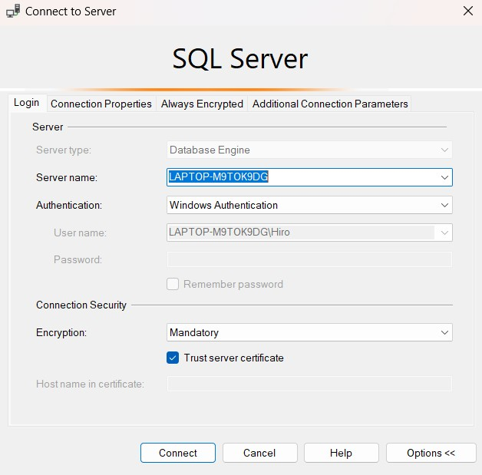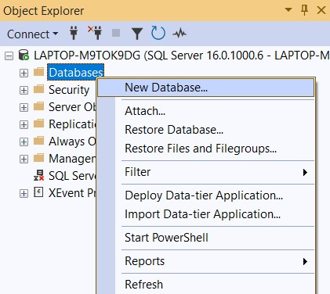

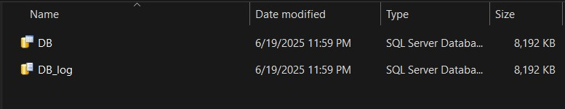

# Lab 3: Relational Database Model Implementation

Step 1: Create New Query

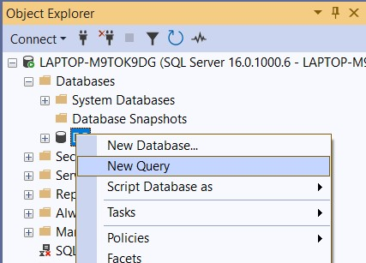

Step 2: Execute after writing Query

Create Table StudentDetails

(

Rollno Int,

StudentName Varchar(100)

)

Create Table SubjectDetails

(

SubjectID Int,

SubjectName Varchar(100)

)

Create Table MarksheetDetails

(

Rollno Int,

SubjectID Int,

Marks Int

)

Step 3: Create New Database Diagram & add tables

